**MVC Student&Teacher**

**(Creating an MVC Application with CRUD and Search operation)**

**(Github Link:** [**https://github.com/PRATHAM271202/DOTNET**](https://github.com/PRATHAM271202/DOTNET)**)**

**⇒ Output:**

**⇒ Index Page:**

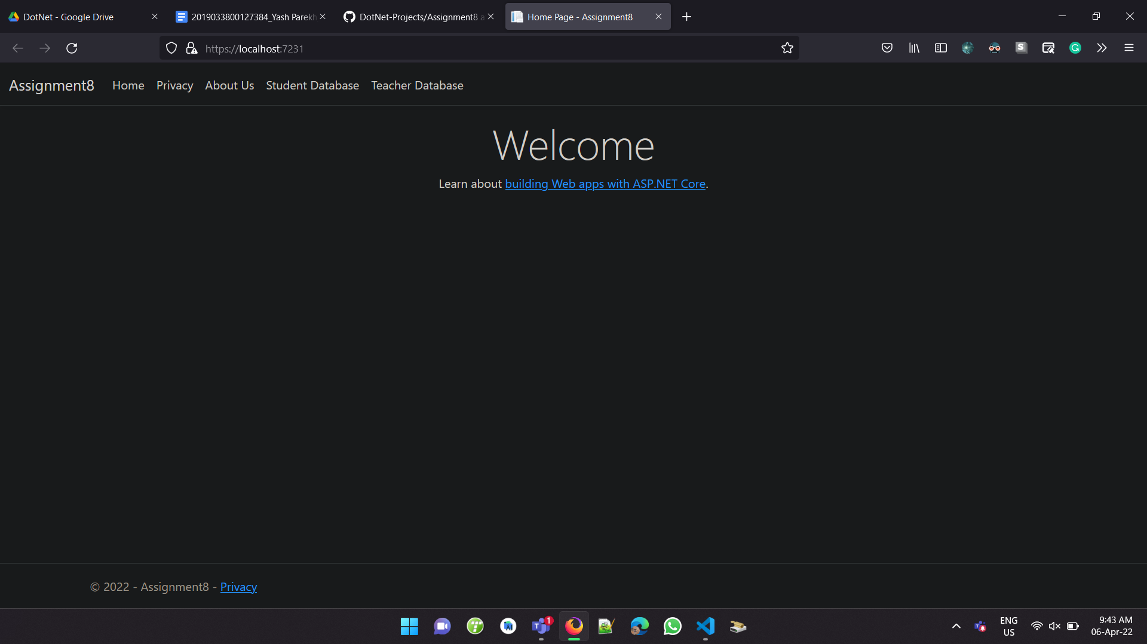

**⇒ Privacy Policy Page:**

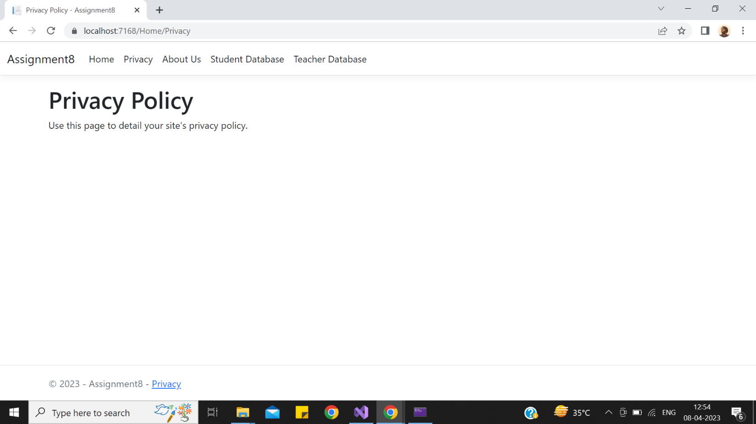

**⇒ About Us Page:**

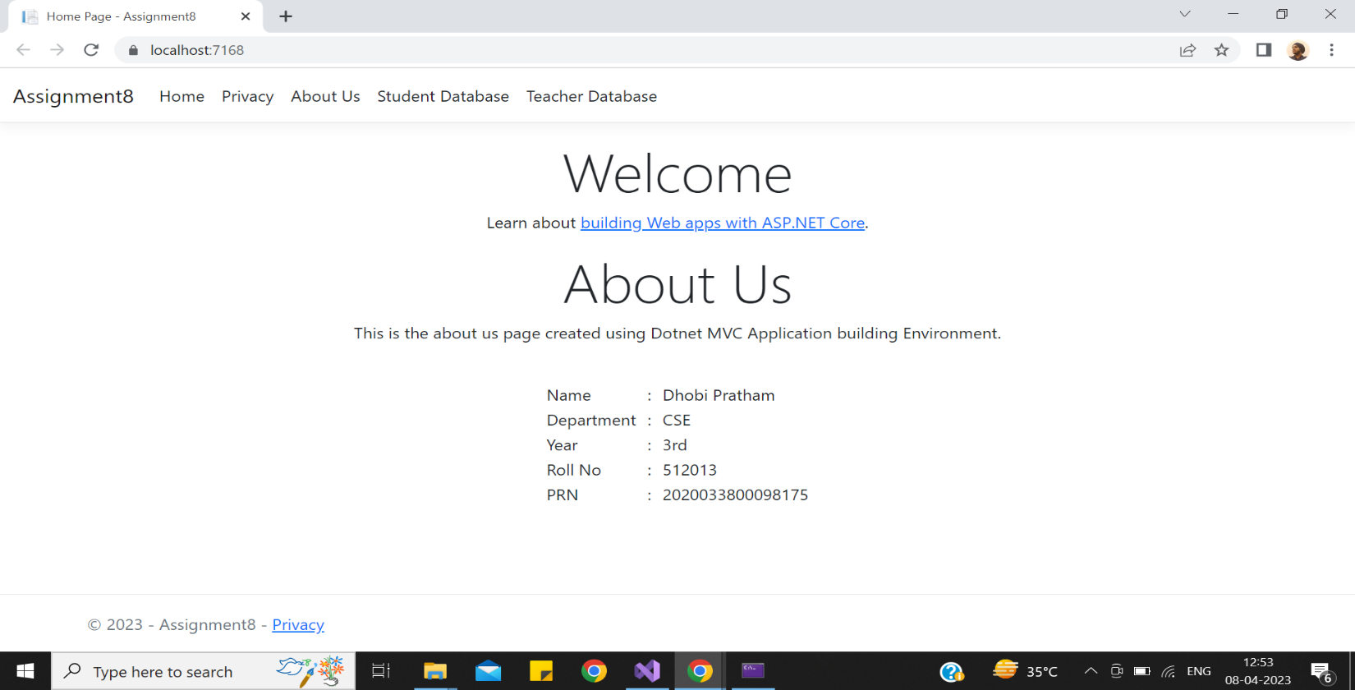

**⇒ Student List:**

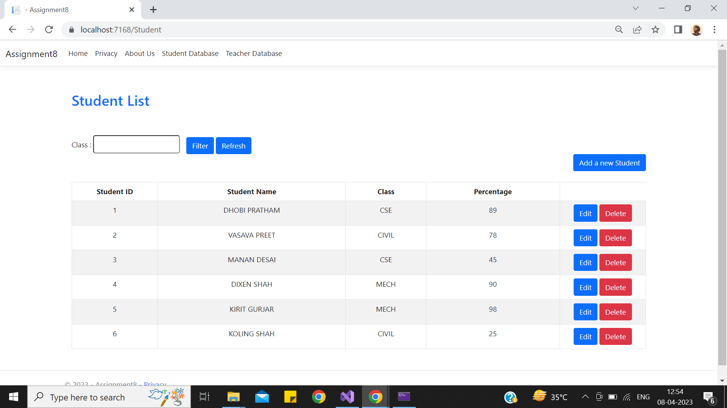

**⇒ Adding New Student:**

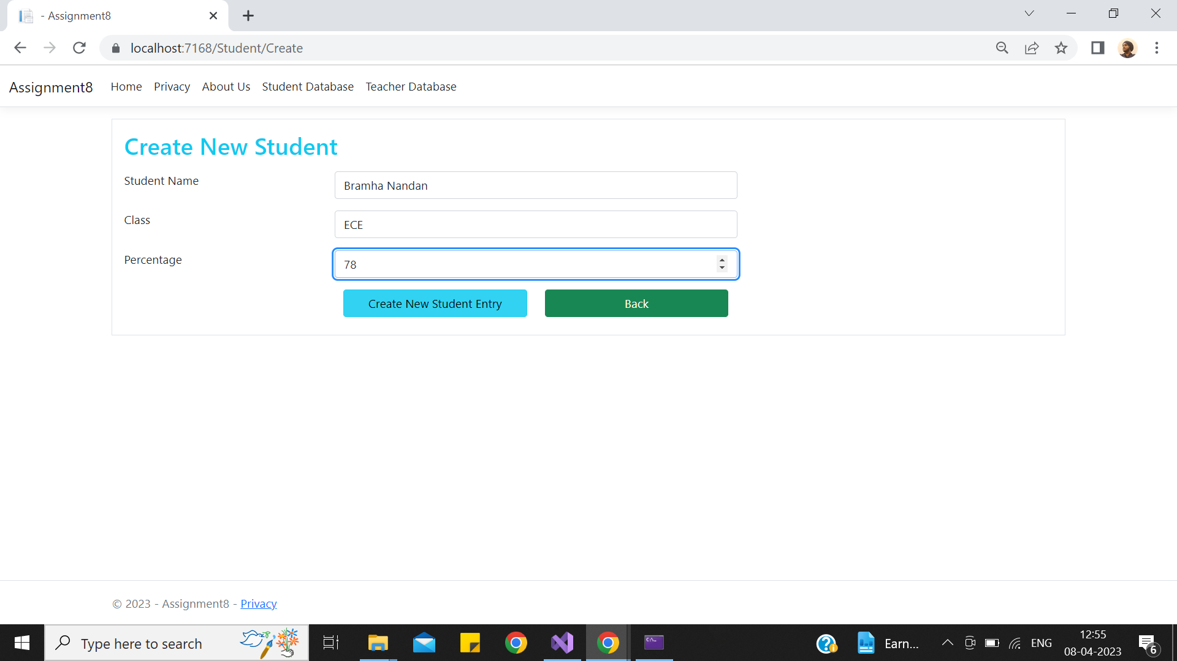

**⇒ After Adding :**

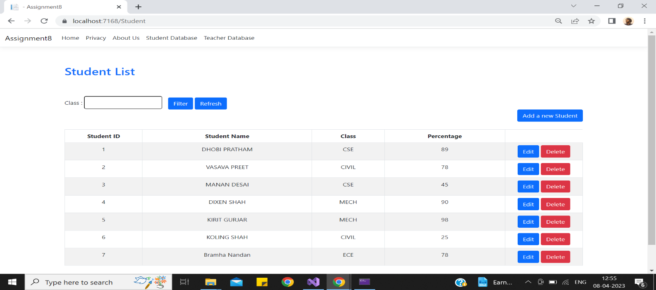

**⇒ Editing :**

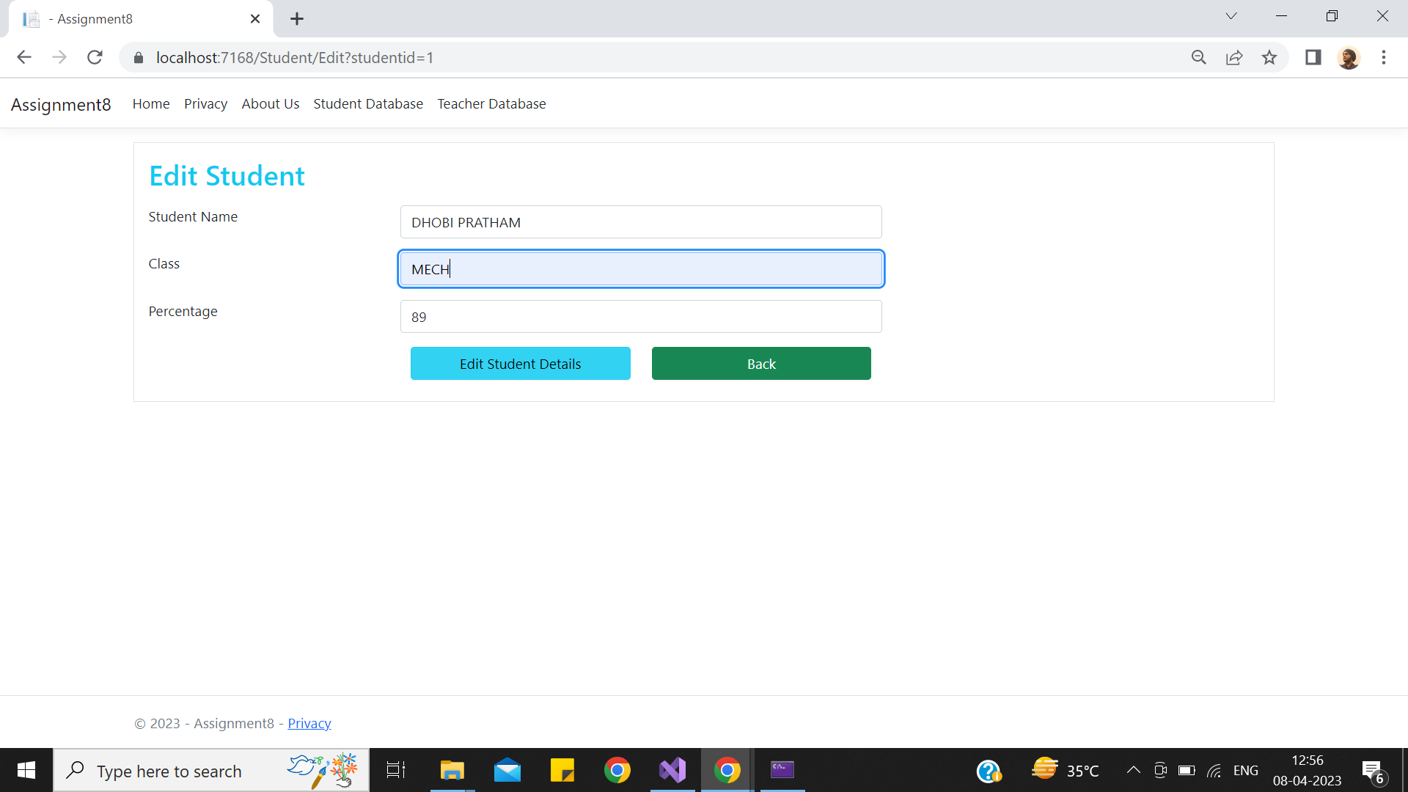

**⇒ Filter operation :**

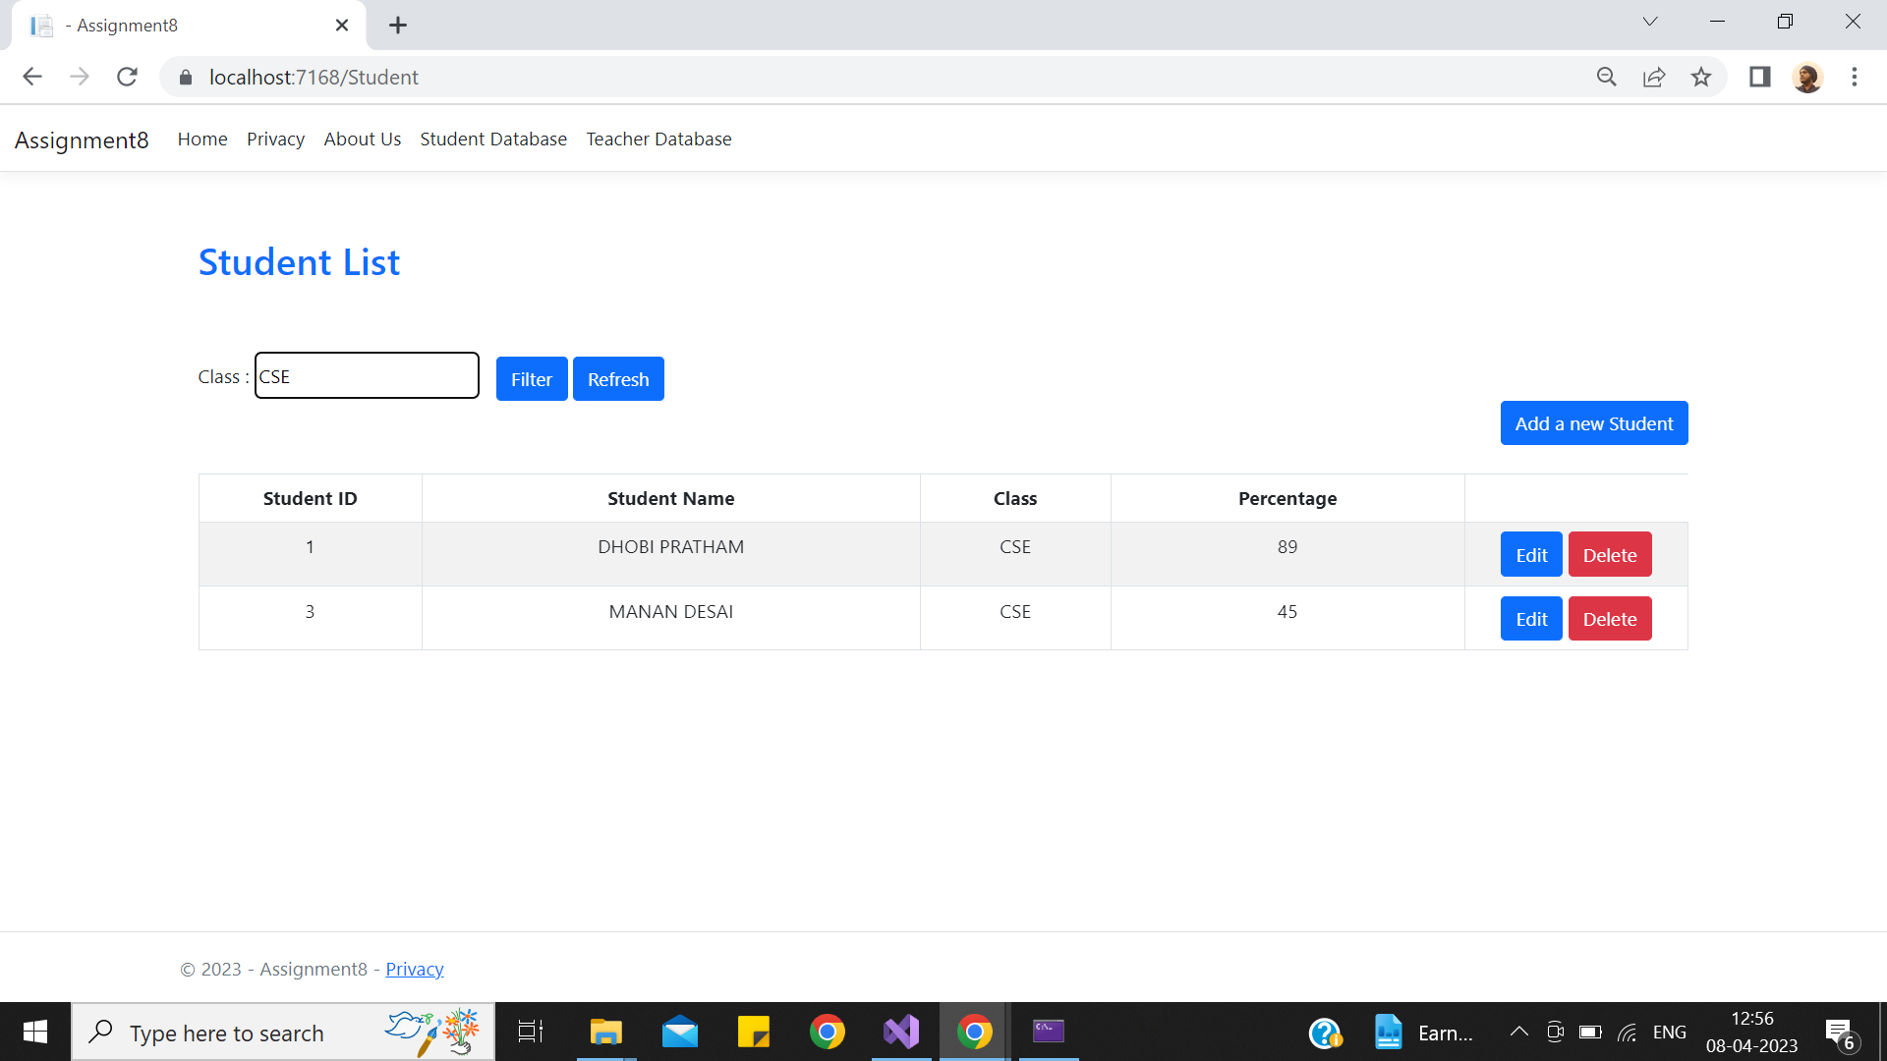

**Creating a Api Using get&post Method**

**(API Call by user interface & JavaScript, validation by postman )**

**⇒ Output At User-interface:**

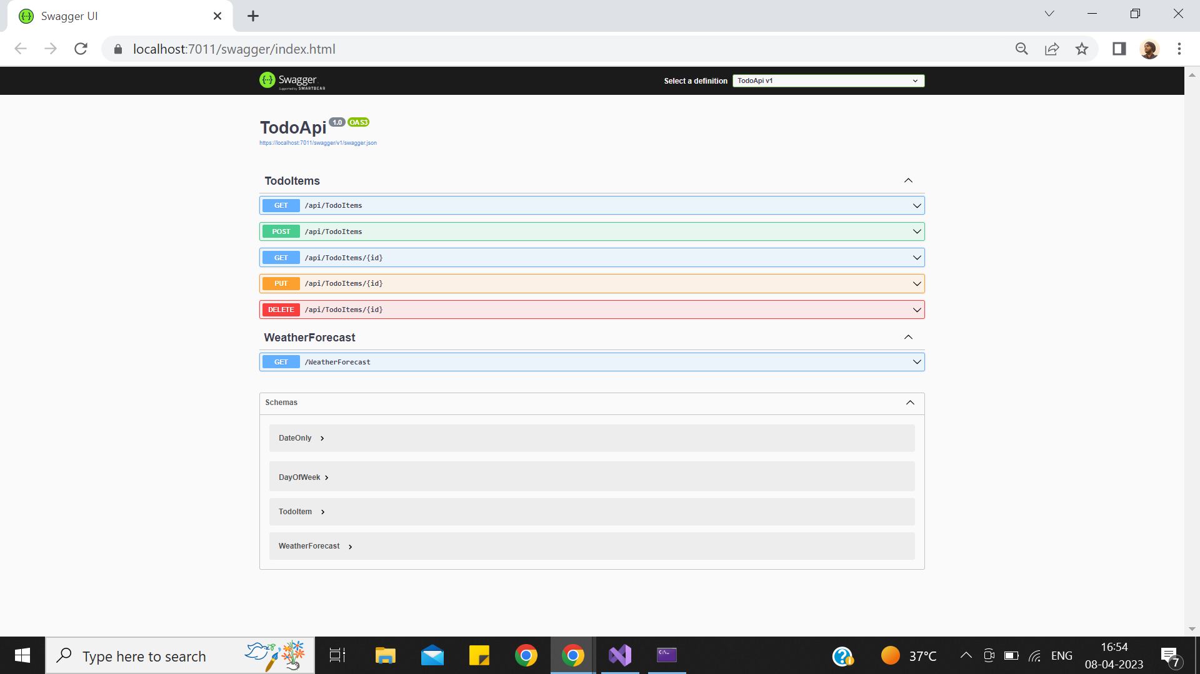

**⇒ Get Method Call At User-interface:**

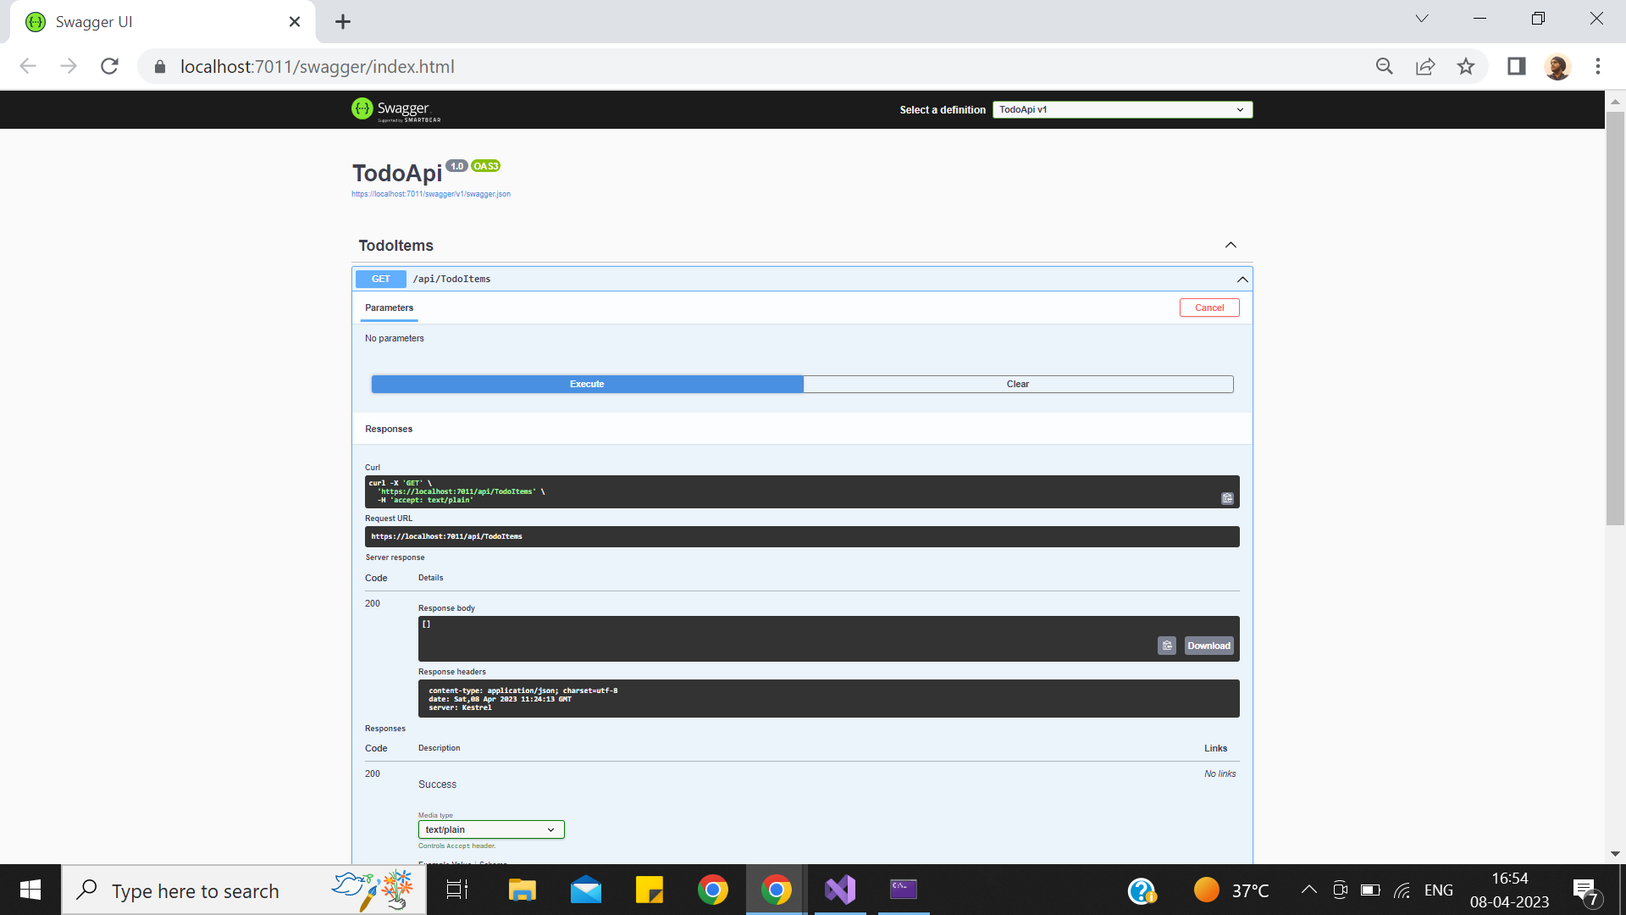

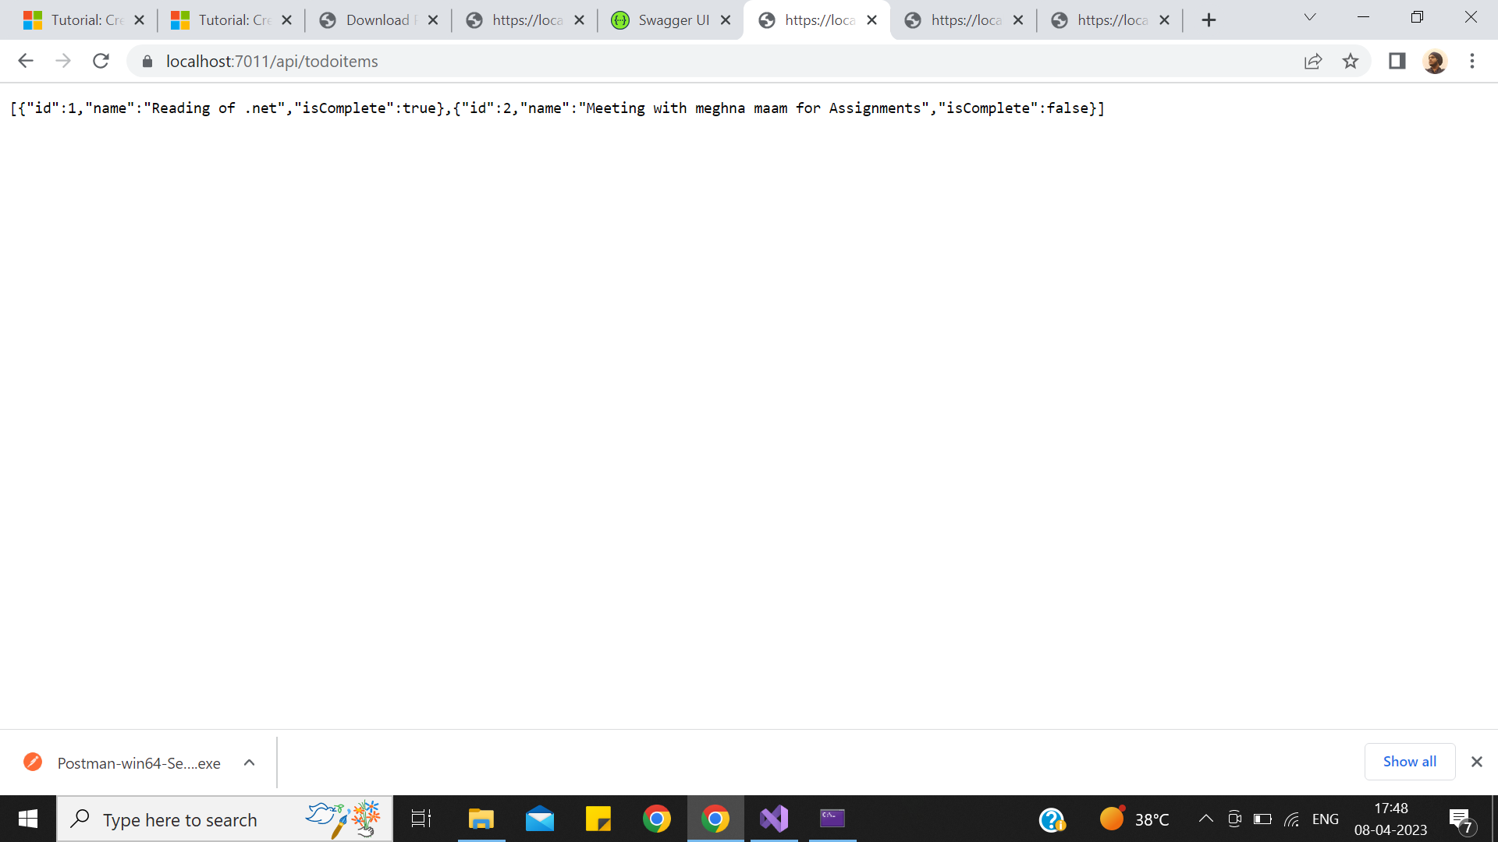

**⇒Post Method Call At User-interface:**

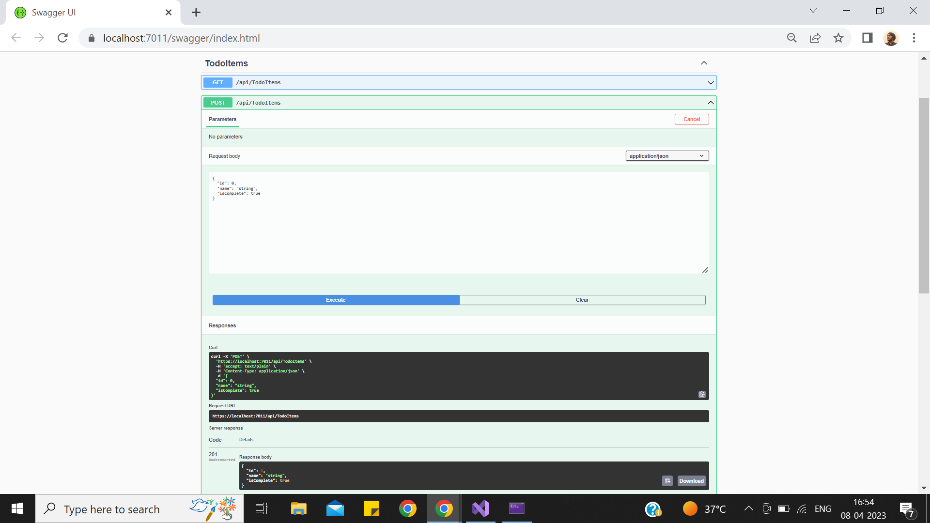

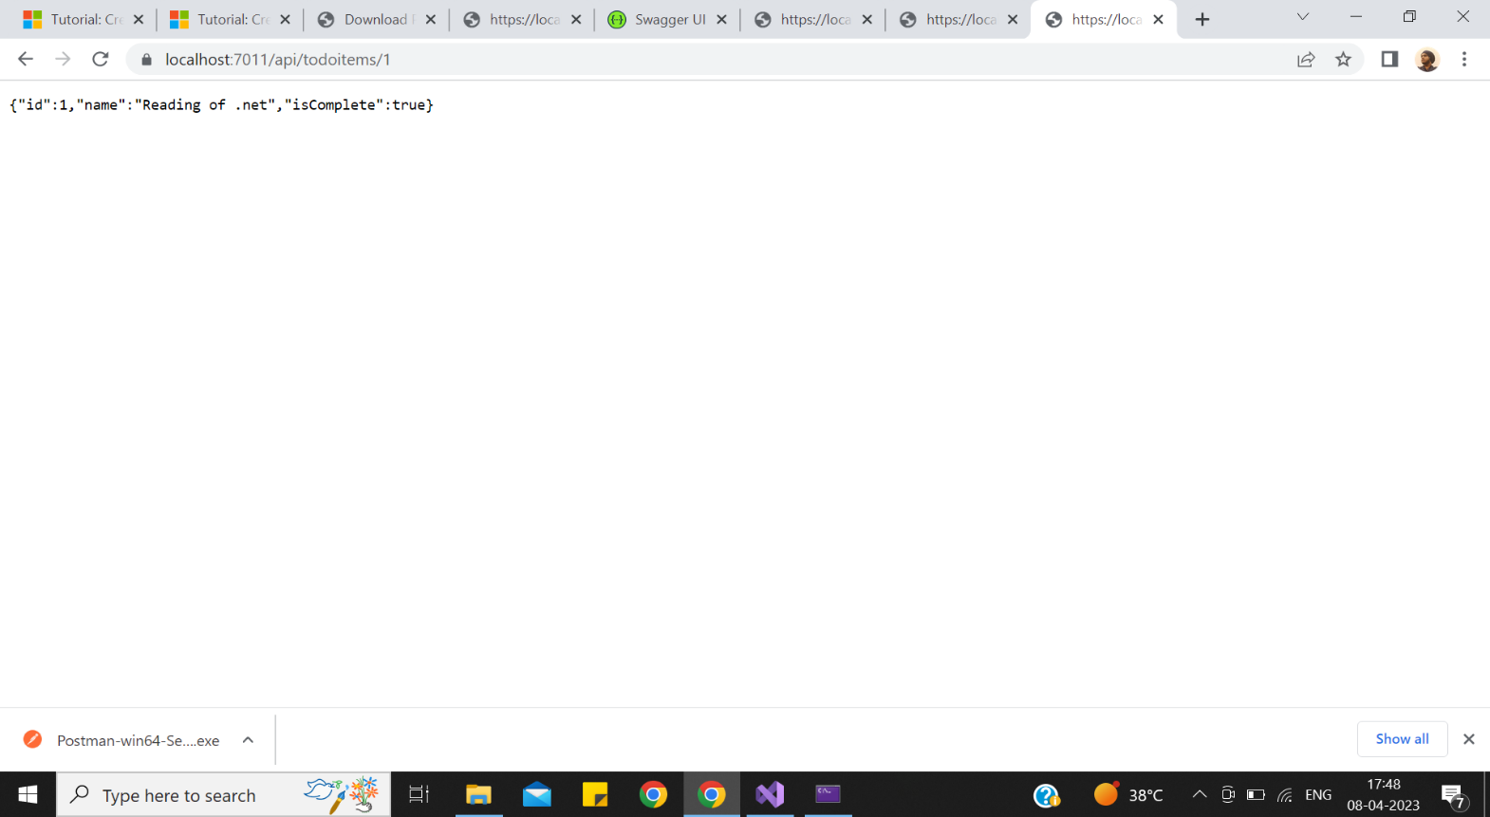

**⇒Api Call Using JavaScript:**

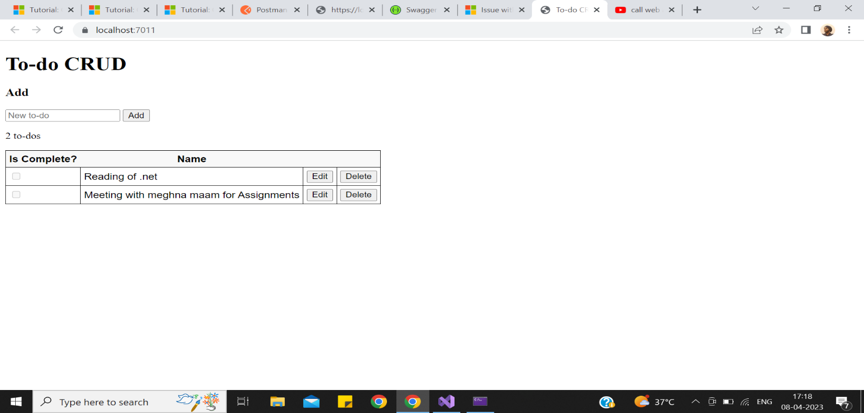

**Edit :**

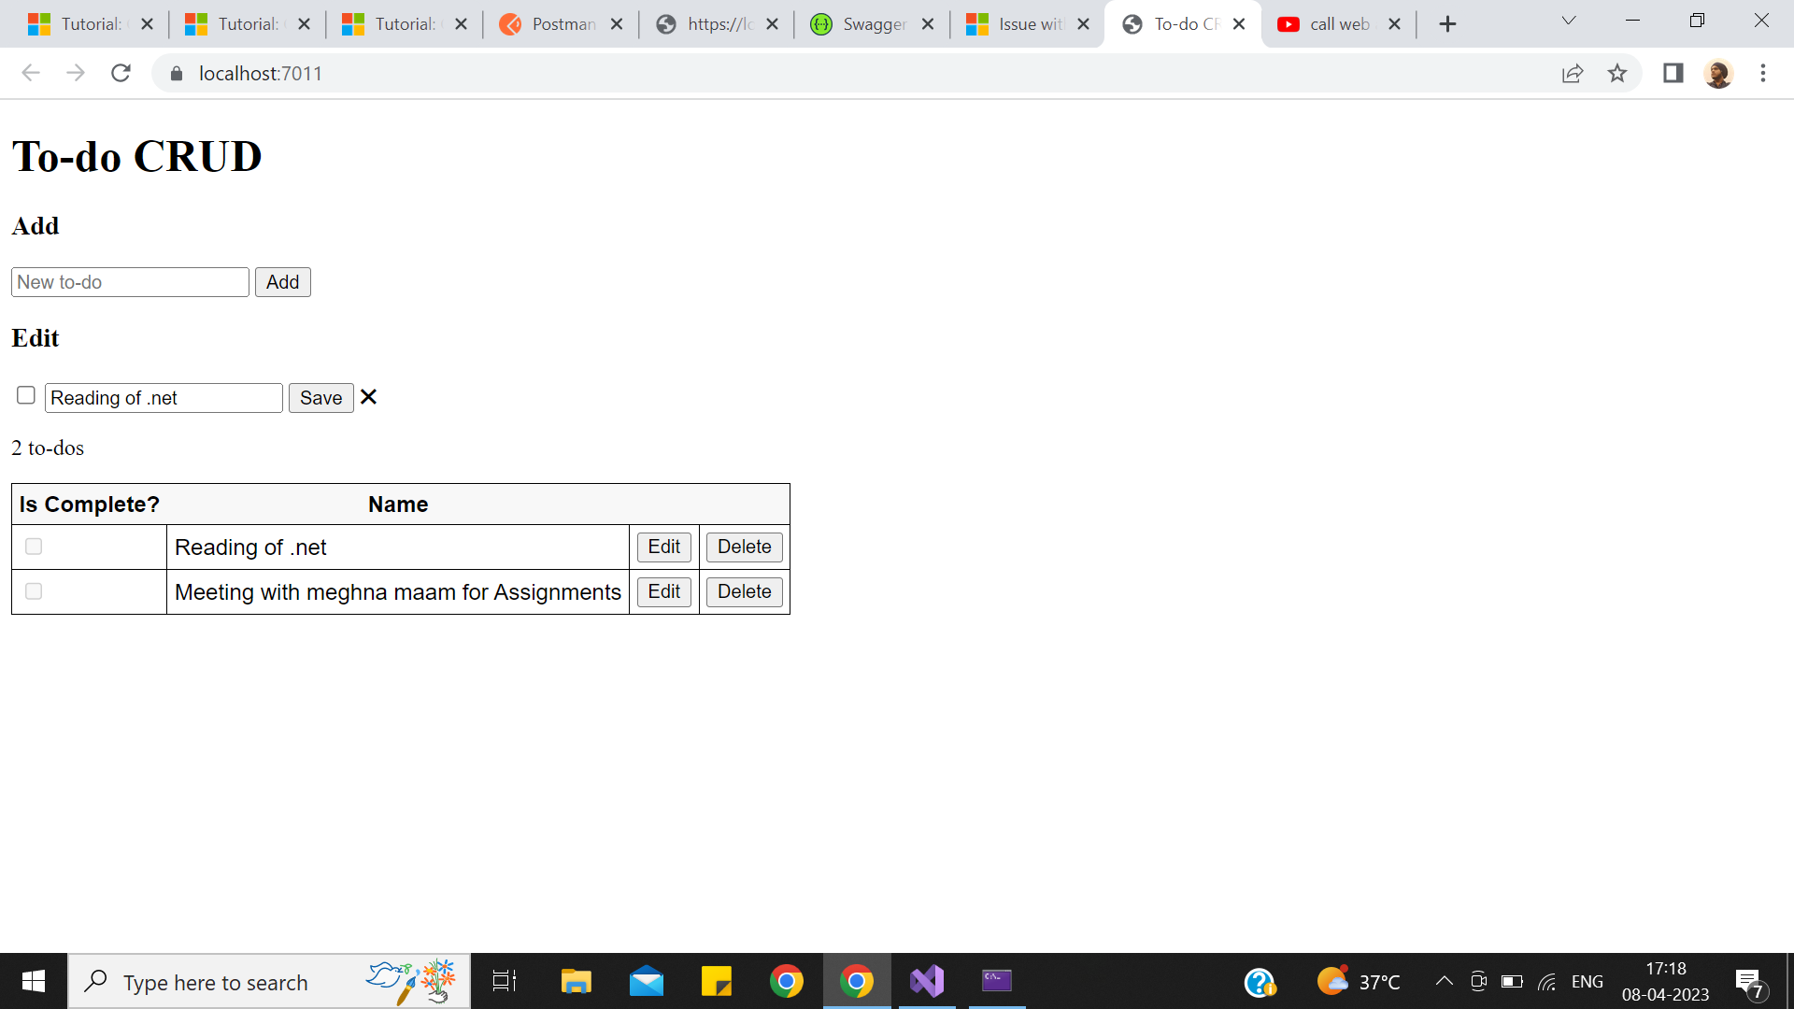

**⇒Api Validation Of both Get And Post Method Using Postman :**



